A Comparative Study of Non-Preemptive Priority, Rate Monotonic (RM), and Earliest Deadline First (EDF) CPU Scheduling Algorithms
Operating Systems / Real-Time Systems — Course Assignment
Prepared by: Ali Naviani
Instructor: majid shamshirgaran
Date: October 2026

Table of Contents
- Introduction
- CPU Scheduling Fundamentals and Performance Metrics
- Non-Preemptive Priority Scheduling
- Rate Monotonic (RM) Scheduling
- Earliest Deadline First (EDF) Scheduling
- Case Study A — Moderately Loaded Task Set
- Case Study B — High-Utilization Task Set
- Comparative Analysis
- Discussion
- Conclusion
References

1. Introduction
CPU scheduling is one of the central responsibilities of an operating system. Whenever multiple processes or tasks compete for a single processor, the scheduler determines which task should execute next. The selected scheduling policy affects waiting time, turnaround time, response time, processor utilization, and, in real-time systems, the ability to meet deadlines.
This report presents a comparative study of three CPU scheduling algorithms:
- Non-Preemptive Priority Scheduling — assigns a priority to each process and selects the highest-priority process among those that are ready. Once a process starts executing, it continues until completion.
- Rate Monotonic (RM) — a fixed-priority, preemptive scheduling algorithm designed for periodic real-time tasks. Tasks with shorter periods receive higher priorities.
- Earliest Deadline First (EDF) — a dynamic-priority, preemptive algorithm that selects the ready job with the earliest absolute deadline.
These algorithms represent different scheduling strategies. Non-Preemptive Priority uses manually assigned priorities and does not interrupt a running process. RM assigns priorities according to task periods and supports preemption. EDF dynamically selects tasks according to their deadlines.
The objectives of this report are threefold. First, it explains the operating principles of each algorithm using descriptions, flowcharts, and pseudocode. Second, it evaluates the algorithms through simulation using common periodic task sets. Third, it compares their performance using standard scheduling metrics, including average waiting time, average turnaround time, average response time, CPU idle time, processor utilization, and deadline satisfaction.
Two case studies are used. Case Study A examines a moderately loaded periodic task set to compare the behavior of the algorithms under relatively manageable processor demand. Case Study B examines a high-utilization task set to investigate how scheduling decisions affect deadline satisfaction under greater processor load.
The simulations provide a practical way to observe scheduling behavior. However, theoretical properties and experimental results must be interpreted separately because each algorithm follows different scheduling rules and may produce different execution timelines.

2. CPU Scheduling Fundamentals and Performance Metrics
Before comparing the algorithms, it is necessary to define the main concepts and metrics used throughout this report.
In a real-time scheduling system, a task represents a recurring unit of work, while a job represents one specific instance of that task. A periodic task generates new jobs at regular intervals. Each job requires a certain amount of processor time and may have a deadline by which it must complete.
The scheduler selects which ready job should execute. Depending on the scheduling algorithm, this decision may be based on manually assigned priority, task period, or deadline.

2.1 Preemptive vs. Non-Preemptive Scheduling
A non-preemptive scheduler allows a process to continue executing after it has been selected until it finishes. The scheduler does not forcibly interrupt the running process merely because another process with a higher priority becomes ready.
Non-Preemptive Priority Scheduling follows this approach. It considers the priorities of ready processes when selecting the next process, but the selected process retains the CPU until completion.
A preemptive scheduler can interrupt a running job and allow another job to execute. Preemption may occur when a higher-priority job arrives or when the scheduling algorithm determines that another ready job should execute first.
Rate Monotonic and Earliest Deadline First are preemptive algorithms in the implementations considered in this report. This allows them to respond to newly released jobs whose fixed priorities or deadlines make them more urgent than the currently running job.
The distinction is important because a non-preemptive algorithm may delay an urgent job until the currently running process completes.

2.2 Key Performance Metrics
The following metrics are used to evaluate the algorithms.
- Arrival Time: The time at which a process or job becomes ready for execution.
- Burst Time: The total amount of CPU time required by a process or job.
- Start Time: The time at which a job first begins executing.
- Completion Time: The time at which a job finishes execution.
- Turnaround Time: The total time between arrival and completion.
- Waiting Time: The total time a job spends waiting in the ready queue.
- Response Time: The time between arrival and the first execution of a job.
- CPU Busy Time: The total time during which the CPU executes jobs.
- CPU Idle Time: The total time during which no job is available for execution.
- CPU Utilization: The percentage of the simulation interval during which the CPU is busy.
- Deadline Miss: An event in which a job completes after its absolute deadline.
For real-time systems, a schedule is considered feasible when every job completes no later than its deadline.

2.3 Scheduling Equations
The main performance metrics are calculated using the following equations.
Turnaround Time
Turnaround time measures the total time a job spends in the system.
[
TAT = Completion\ Time - Arrival\ Time
]
Waiting Time
For a completed job, waiting time can be calculated as:
[
WT = TAT - Burst\ Time
]
This formula measures the total time the job spends waiting rather than executing.
Response Time
Response time measures how long a job waits before its first execution.
[
RT = Start\ Time - Arrival\ Time
]
For a non-preemptive process, response time is the initial waiting period before execution begins. For a preemptive job, it measures the delay before the job first receives the CPU.
CPU Utilization
CPU utilization measures the proportion of the simulation interval spent executing jobs.
[
U_{CPU} = \frac{CPU\ Busy\ Time}{Total\ Simulation\ Time}\times100
]
CPU Idle Time
CPU idle time is calculated as:
[
Idle\ Time = Total\ Simulation\ Time - CPU\ Busy\ Time
]
Average Waiting Time
For (n) completed jobs:
[
AvgWT = \frac{\sum_{i=1}^{n}WT_i}{n}
]
Average Turnaround Time
[
AvgTAT = \frac{\sum_{i=1}^{n}TAT_i}{n}
]
Average Response Time
[
AvgRT = \frac{\sum_{i=1}^{n}RT_i}{n}
]
Periodic Task Utilization
For a set of periodic tasks, theoretical utilization is calculated as:
[
U = \sum_{i=1}^{n}\frac{C_i}{T_i}
]
where (C_i) represents the computation time of task (i), and (T_i) represents its period.
This theoretical utilization estimates the long-term fraction of processor capacity demanded by the periodic tasks. It should not automatically be treated as equal to measured CPU utilization in a finite simulation, particularly when the simulation ends while jobs remain unfinished.

3. Non-Preemptive Priority Scheduling

3.1 Description
Non-Preemptive Priority Scheduling selects the ready process with the highest assigned priority whenever the CPU becomes available. In this report, a smaller numerical priority value represents a higher priority.
For example, a process with priority 1 has higher priority than a process with priority 3. If multiple processes have the same priority, the implementation resolves ties by considering arrival time and then process ID.
After a process is selected, it executes until completion. If a higher-priority process arrives while another process is running, the running process is not interrupted. The newly arrived process must wait until the CPU becomes available.
The algorithm is relatively straightforward to implement because it does not require preemption or continuous rescheduling of a running process. However, it can produce long response times for urgent processes that arrive while a lower-priority process is executing.
A major disadvantage is the possibility of starvation. If higher-priority processes continue to arrive, a low-priority process may wait for a long time before receiving CPU time. Priority aging can reduce this problem, but it is not part of the basic implementation considered here.
Non-Preemptive Priority Scheduling differs from RM. In the priority algorithm, priorities are assigned explicitly to processes. In RM, priorities are determined by task periods, and running jobs may be preempted.

3.2 Flowchart
The scheduling decision follows this sequence:
- Start the scheduler.
- Check whether any process has arrived and is ready.
- If no process is ready, advance the simulation time until the next arrival or relevant event.
- If one or more processes are ready, select the process with the smallest numerical priority value.
- If priorities are equal, apply the defined tie-breaking rules.
- Execute the selected process until completion.
- Record its start time, completion time, waiting time, turnaround time, and response time.
- Repeat until the simulation ends or all required processes have been handled.
Figure 3.1 — Flowchart of the Non-Preemptive Priority scheduling decision logic.
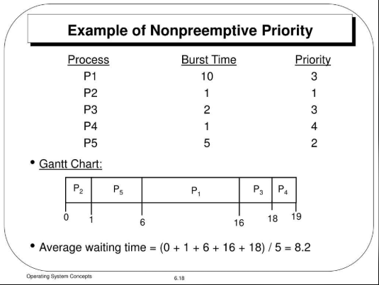
Insert a flowchart illustrating the steps above.

3.3 Pseudocode
ALGORITHM NonPreemptivePriorityScheduler

Input:
processes with arrival_time, burst_time, and priority

current_time <- 0
completed <- empty list

while unfinished processes remain:

ready <- all arrived processes that are not completed

if ready is empty:
advance current_time to the next arrival time
continue

selected <- process in ready with:
smallest priority value
then earliest arrival time
then smallest process ID

start_time <- current_time
completion_time <- start_time + selected.burst_time

turnaround_time <- completion_time
- selected.arrival_time

waiting_time <- turnaround_time
- selected.burst_time

response_time <- start_time
- selected.arrival_time

record all calculated metrics

current_time <- completion_time
mark selected as completed

end while

calculate average metrics
calculate CPU busy time and idle time
calculate CPU utilization

END ALGORITHM

3.4 Advantages and Disadvantages
Advantages
- Simple to understand and implement.
- Supports explicit priority assignments based on application requirements.
- Does not require interruption of a running process.
- Produces predictable execution once a process has started.
- Can favor important processes when the CPU becomes available.
Disadvantages
- A high-priority process may wait for a lower-priority process to finish.
- Long-running processes can increase waiting and response times for other processes.
- Low-priority processes may suffer starvation under sustained high-priority demand.
- Priority assignment depends on the designer or application.
- The algorithm does not automatically adjust priorities based on task deadlines.
The algorithm is useful for systems in which simplicity and explicit process importance are important. However, its non-preemptive behavior may limit its effectiveness in systems requiring strict real-time deadline guarantees.

4. Rate Monotonic (RM) Scheduling

4.1 Description
Rate Monotonic Scheduling is a fixed-priority, preemptive algorithm designed for periodic real-time tasks. The algorithm assigns priorities according to task periods: a shorter period receives a higher priority.
For example, if Task A has a period of 5 time units and Task B has a period of 10 time units, Task A receives the higher RM priority.
The priority assigned to a task remains fixed. Individual jobs released by that task inherit the same priority. At runtime, the scheduler selects the ready job with the highest RM priority. If a higher-priority job becomes ready while a lower-priority job is running, the lower-priority job can be preempted.
Liu and Layland established a classical sufficient schedulability bound for independent periodic tasks with deadlines equal to their periods. For (n) tasks, the bound is:
[
U \leq n(2^{1/n}-1)
]
As the number of tasks approaches infinity, the bound approaches approximately 0.693, or 69.3%.
This is a sufficient condition rather than a necessary condition. If a task set exceeds the bound, it is not automatically unschedulable; a more detailed analysis may still show that all deadlines can be met.
RM is attractive because its priorities are static, which simplifies priority assignment and can make system analysis easier. However, a task's priority is determined by its period rather than by the urgency of each individual job.
The classical bound applies under specific assumptions, including a single processor, independent periodic tasks, preemptive scheduling, and deadlines equal to periods. It should not be applied without qualification to arbitrary task models.

4.2 Flowchart
The scheduling decision follows this sequence:
- Start the scheduler.
- Generate or identify newly released jobs.
- Add released jobs to the ready set.
- Select the ready job belonging to the task with the shortest period.
- If a higher-priority job becomes ready, preempt the currently running job.
- Execute the selected job.
- When a job completes, record its completion time and check its deadline.
- If no job is ready, allow the CPU to remain idle.
- Continue until the simulation horizon is reached.
Figure 4.1 — Flowchart of the Rate Monotonic scheduling decision logic.
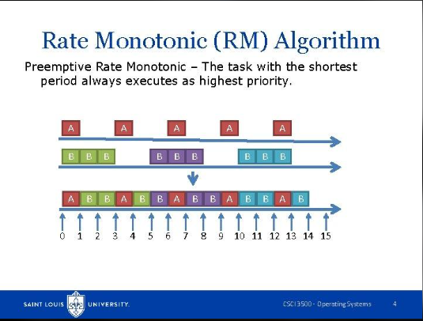
Insert a flowchart illustrating the steps above.

4.3 Pseudocode
ALGORITHM RateMonotonicScheduler

Input:
periodic tasks with computation_time and period

for each task:
assign higher priority to shorter periods

while simulation is running:

release jobs whose release times have been reached

ready <- all released jobs that are not completed

if ready is not empty:

selected <- ready job with the highest RM priority

if selected differs from the running job:
preempt the current job if necessary
dispatch selected

execute selected for the next scheduling interval

if selected has completed:
record completion time
check whether its deadline was met

else:
CPU remains idle

end while

calculate performance metrics

END ALGORITHM

4.4 Advantages and Disadvantages
Advantages
- Fixed priorities make the scheduling policy relatively easy to analyze.
- Short-period tasks receive consistent priority.
- Preemption allows urgent high-priority jobs to execute without waiting for a lower-priority job to finish.
- RM has a well-established theoretical foundation for periodic real-time scheduling.
- Static priority assignment can simplify implementation and testing.
Disadvantages
- A task with a longer period may receive a lower priority even when one of its jobs has an approaching deadline.
- The classical utilization bound is sufficient but not necessary.
- Lower-priority tasks may experience long response times under heavy processor demand.
- The algorithm cannot dynamically change a task's priority according to each job's absolute deadline.
- A task set with utilization below 100% may still be unschedulable under RM.
RM is useful when fixed priorities and predictable priority assignments are desirable. Its performance depends on the task set, computation times, periods, deadlines, and the assumptions under which the scheduling policy is applied.

5. Earliest Deadline First (EDF) Scheduling

5.1 Description
Earliest Deadline First is a dynamic-priority, preemptive scheduling algorithm. Unlike RM, EDF does not assign each task a permanent priority based only on its period. Instead, it evaluates the absolute deadlines of ready jobs and selects the job whose deadline is earliest.
The absolute deadline of a job is calculated using its release time and relative deadline:
[
D_{absolute}=Arrival\ Time+D_{relative}
]
For example, if a job arrives at time 5 and has a relative deadline of 4 time units, its absolute deadline is time 9.
Whenever a new job arrives or a scheduling decision is required, EDF compares the deadlines of ready jobs. If a newly released job has an earlier absolute deadline than the running job, the running job can be preempted.
For a single processor and an ideal preemptive scheduling model, EDF is optimal for meeting deadlines: if a feasible schedule exists for a given set of independent jobs under the relevant assumptions, EDF can also produce a feasible schedule.
For periodic tasks with deadlines equal to their periods, the utilization condition is:
[
U=\sum_{i=1}^{n}\frac{C_i}{T_i}\leq1
]
Under the classical assumptions, this condition is necessary and sufficient for EDF feasibility on a single processor.
However, this guarantee depends on the task model and assumptions. It should not be interpreted as a universal guarantee for arbitrary systems with blocking, dependencies, resource contention, scheduling overhead, or other practical constraints.
EDF can achieve high processor utilization while meeting deadlines. Its main implementation challenge is that priorities must be determined dynamically. Under overload, multiple jobs may miss deadlines, and the behavior may be less predictable than that of a fixed-priority policy.

5.2 Flowchart
The scheduling decision follows this sequence:
- Start the scheduler.
- Generate newly released jobs.
- Calculate the absolute deadline of each new job.
- Add the jobs to the ready set.
- Select the ready job with the earliest absolute deadline.
- Preempt the current job if the selected job has an earlier deadline.
- Execute the selected job.
- Record completion time and determine whether its deadline was met.
- If no job is ready, allow the CPU to remain idle.
- Repeat until the simulation ends.
Figure 5.1 — Flowchart of the Earliest Deadline First scheduling decision logic.
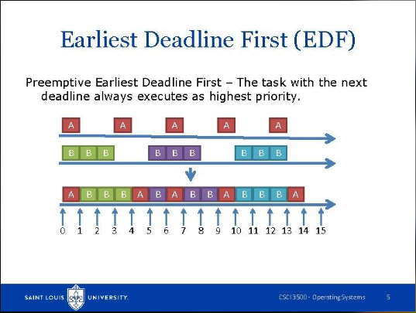
Insert a flowchart illustrating the steps above.

5.3 Pseudocode
ALGORITHM EDFScheduler

Input:
periodic tasks with computation_time,
period, and relative_deadline

when a job is released:

job.absolute_deadline <-
job.release_time + job.relative_deadline

add job to the ready set

while simulation is running:

release all jobs due at the current time

ready <- all released jobs that are not completed

if ready is not empty:

selected <- ready job with the earliest absolute deadline

if selected differs from the running job:
preempt the current job if necessary
dispatch selected

execute selected for the next scheduling interval

if selected has completed:
record completion time
check whether completion_time <= absolute_deadline

else:
CPU remains idle

end while

calculate performance metrics

END ALGORITHM
5.4 Advantages and Disadvantages
Advantages
- Dynamically prioritizes jobs according to deadline urgency.
- Can meet all deadlines for feasible task sets under the classical single-processor assumptions.
- Can achieve processor utilization up to 100% in the ideal schedulable case.
- Adapts its scheduling decisions when jobs with different deadlines arrive.
- Is suitable for studying deadline-driven real-time workloads.
Disadvantages
- Requires dynamic deadline comparisons during scheduling.
- May have higher scheduling overhead than fixed-priority RM.
- Behavior under overload can be difficult to predict.
- Practical systems may not achieve theoretical guarantees when additional constraints are present.
- Runtime scheduling decisions are more dependent on the current set of ready jobs.
EDF is particularly useful when deadlines vary across jobs and dynamic urgency is important. Its effectiveness depends on the workload and the assumptions of the scheduling model.
6. Case Study A — Moderately Loaded Task Set
To compare the three algorithms under the same workload, a periodic task set is simulated using Non-Preemptive Priority, RM, and EDF.
The task set is designed to provide a moderately loaded processor workload. All algorithms receive jobs generated from the same periodic task definitions. However, they make different scheduling decisions because their priority rules and preemption behavior differ.
6.1 Task Set Definition
The following periodic tasks are used in Case Study A.
Task | Computation Time (C) | Period (T) | Priority | Relative Deadline (D)
T1 | 1 | 5 | 3 | 4
T2 | 2 | 7 | 1 | 6
T3 | 1 | 10 | 2 | 8
For Non-Preemptive Priority Scheduling, a smaller numerical priority indicates a higher priority. Therefore, T2 has the highest assigned priority, followed by T3 and T1.
RM does not use these manually assigned priority values. Instead, RM assigns its highest priority to the task with the shortest period. EDF uses each job's absolute deadline to determine which job should execute next.
The simulation horizon is 30 time units.
The theoretical utilization is:
[
U=\frac{1}{5}+\frac{2}{7}+\frac{1}{10}
]
[
U\approx0.5857=58.57%
]
This utilization represents the long-term processor demand of the periodic task set. Measured utilization over the finite simulation interval may differ because of the exact job releases and the simulation's treatment of the ending boundary.
6.2 Gantt Charts
A Gantt chart illustrates when each job executes during the simulation. It provides a visual comparison of the order of execution, preemption, and idle intervals.
Three schedules are generated:
- Non-Preemptive Priority schedule.
- Rate Monotonic schedule.
- Earliest Deadline First schedule.
Figure 6.1 — Non-Preemptive Priority schedule for Case Study A.
Insert the Gantt chart generated by the Non-Preemptive Priority implementation.
Figure 6.2 — Rate Monotonic schedule for Case Study A.
Insert the Gantt chart generated by the RM implementation.
Figure 6.3 — Earliest Deadline First schedule for Case Study A.
Insert the Gantt chart generated by the EDF implementation.

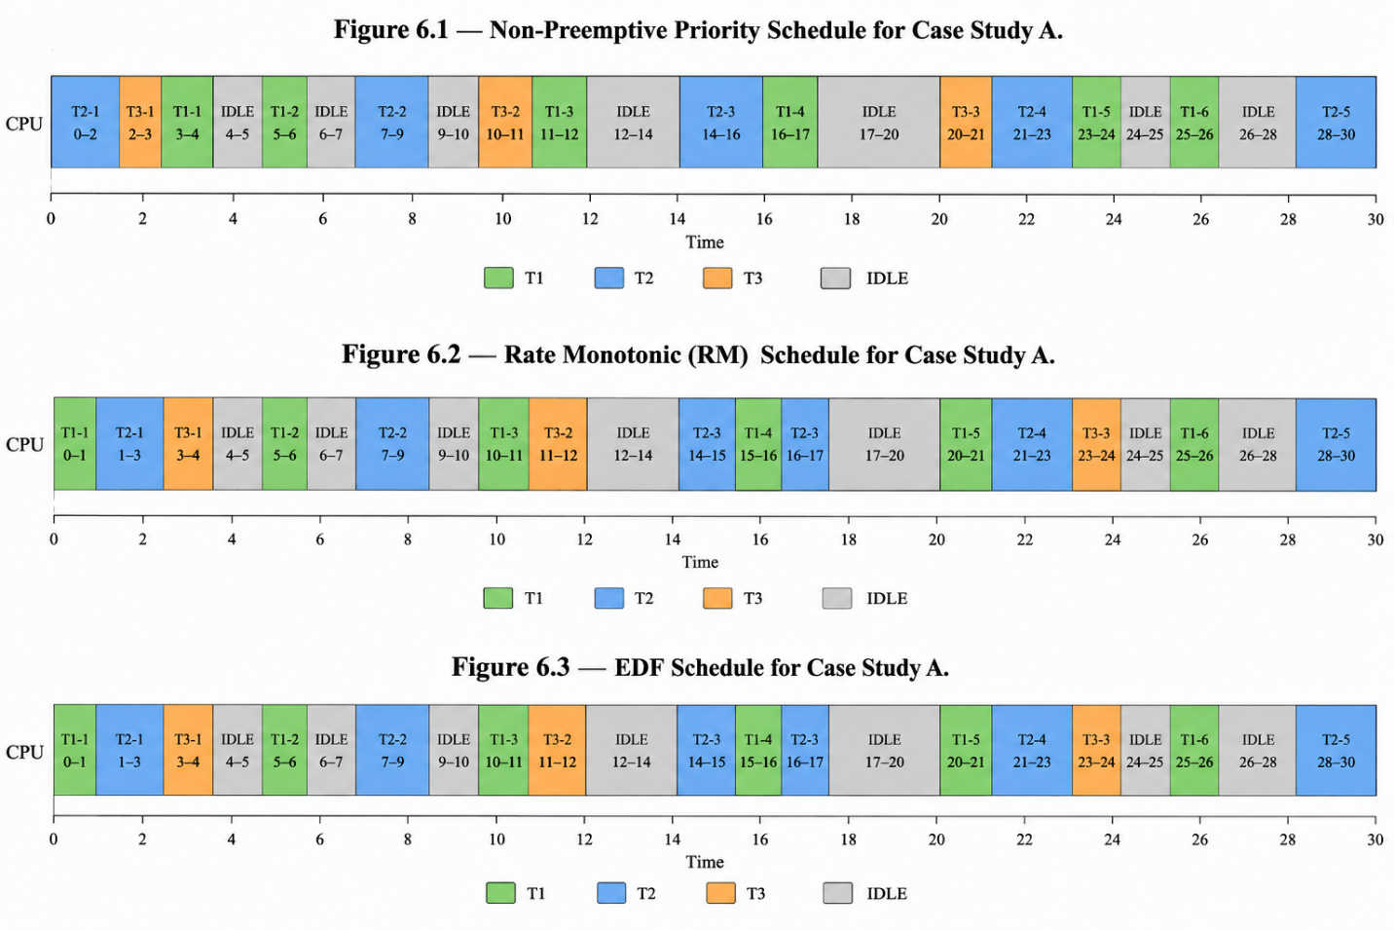

The schedules should be generated from the same simulation horizon and periodic task definitions. Differences in the timelines illustrate how fixed manual priorities, period-based priorities, and deadline-based priorities affect execution order.
6.3 Per-Job Metrics
For each algorithm, the simulator records the performance metrics of individual jobs.
The main columns are:
Metric | Meaning
Job ID | Unique identifier of a released job
Arrival | Time at which the job becomes ready
Burst | Required CPU execution time
Deadline | Absolute deadline of the job
Start | First execution time
Completion | Time at which the job finishes
Turnaround | Completion minus arrival
Waiting | Turnaround minus burst
Response | First start minus arrival
Deadline Status | Whether the job met its deadline
The tables below should contain the actual job-level output of each scheduling implementation.
Non-Preemptive Priority
Insert the per-job metrics table produced by the Priority implementation.
Rate Monotonic
Insert the per-job metrics table produced by the RM implementation.
Earliest Deadline First
Insert the per-job metrics table produced by the EDF implementation.
These tables are important because average metrics alone may hide differences between individual tasks. For example, an algorithm may improve the average waiting time while increasing the waiting time of one particular task.
6.4 Summary of Average Metrics
The following table records the summary metrics for Case Study A. The values shown below are the previously recorded sample results and should be checked against the final program output before submission.
Metric | Non-Preemptive Priority | RM | EDF
Average Waiting Time | 0.71 | 0.64 | 0.64
Average Turnaround Time | 2.07 | 2.00 | 2.00
Average Response Time | 0.71 | 0.57 | 0.57
Completed Jobs | 14 | 14 | 14
Missed Deadlines | 0 | 0 | 0
CPU Busy Time | 19 | 19 | 19
CPU Idle Time | 11 | 11 | 11
Measured CPU Utilization | 63.33% | 63.33% | 63.33%
Figure 6.4 — Average time metrics and CPU utilization for Case Study A.
Insert a chart comparing the average waiting time, turnaround time, and response time of the three algorithms.
The measured CPU utilization in this table is based on 19 busy time units out of a 30-unit simulation interval. It differs from the theoretical utilization of 58.57%, so the task generation, completion handling, and simulation boundaries should be verified against the final code. Do not present these sample figures as verified final results until they match the latest program output.
6.5 Analysis
Case Study A provides a basis for comparing the scheduling algorithms under a moderately loaded periodic workload.
Non-Preemptive Priority selects ready jobs according to explicitly assigned priorities. T2 receives the highest manual priority, while T3 and T1 have lower priorities. However, once a job begins execution, a newly released higher-priority job cannot interrupt it. This may increase the response time of jobs that arrive while the processor is busy.
RM assigns priority according to period. T1 has the shortest period and therefore receives the highest RM priority. The algorithm can preempt a lower-priority job when a higher-priority job becomes ready.
EDF uses absolute deadlines instead of a fixed task priority. Consequently, the execution order can change when jobs with earlier deadlines arrive.
The numerical results should be interpreted using the actual output of the final simulator. Lower average waiting time indicates that jobs spend less time waiting for CPU service. Lower average turnaround time indicates that jobs complete sooner after arrival. Lower response time indicates that jobs begin execution sooner.
Deadline satisfaction must be evaluated separately from these average metrics. A scheduling algorithm can achieve low average waiting time while still missing a deadline for a particular job. Therefore, a complete evaluation should consider both time-based metrics and the number of missed deadlines.
7. Case Study B — High-Utilization Task Set
Case Study B examines a two-task periodic workload with high processor utilization. The purpose is to observe how the algorithms behave when the processor has relatively little spare capacity.
The task set is commonly used to illustrate the distinction between the sufficient schedulability bound for RM and the utilization condition for EDF. In this report, Non-Preemptive Priority is also evaluated, but its behavior must be measured separately because it is non-preemptive and uses manually assigned priorities.
7.1 Task Set Definition
Task | Computation Time (C) | Period (T) | Relative Deadline (D) | Utilization (C/T) | Priority for Non-Preemptive Priority
X | 2 | 5 | 5 | 0.400 | 1
Y | 4 | 7 | 7 | 0.571 | 2
For Non-Preemptive Priority, X has priority 1 and Y has priority 2. Therefore, X has the higher manually assigned priority.
For RM, X receives the higher priority because its period is shorter than Y's period.
For EDF, each job is scheduled according to its absolute deadline.
The utilization is:
[
U=\frac{2}{5}+\frac{4}{7}
]
[
U\approx0.9714=97.14%
]
The hyperperiod, which is the least common multiple of the two periods, is:
[
H=\operatorname{LCM}(5,7)=35
]
The RM sufficient bound for two tasks is:
[
U_{RM}=2(2^{1/2}-1)
]
[
U_{RM}\approx0.8284=82.84%
]
The task set's utilization is above the RM sufficient bound but below 100%. Exceeding the RM bound does not, by itself, prove that RM will miss a deadline; it means the sufficient bound does not guarantee schedulability. The simulation must be used to observe the actual schedule for the specified workload.
Under the classical single-processor assumptions and deadlines equal to periods, EDF's utilization condition is satisfied because (U\leq1). This gives a theoretical basis for expecting a feasible EDF schedule, provided the implementation follows the model's assumptions.
7.2 Gantt Charts
The Gantt charts for Case Study B illustrate how the algorithms allocate CPU time under high utilization.
Figure 7.1 — Non-Preemptive Priority schedule for Case Study B.
Insert the Gantt chart generated by the Non-Preemptive Priority implementation.
Figure 7.2 — Rate Monotonic schedule for Case Study B.
Insert the Gantt chart generated by the RM implementation.
Figure 7.3 — Earliest Deadline First schedule for Case Study B.
Insert the Gantt chart generated by the EDF implementation.
The charts should cover the same 35-unit hyperperiod. If the simulator generates a different number of jobs because of its boundary rules, explain that behavior and use the same rules for all algorithms.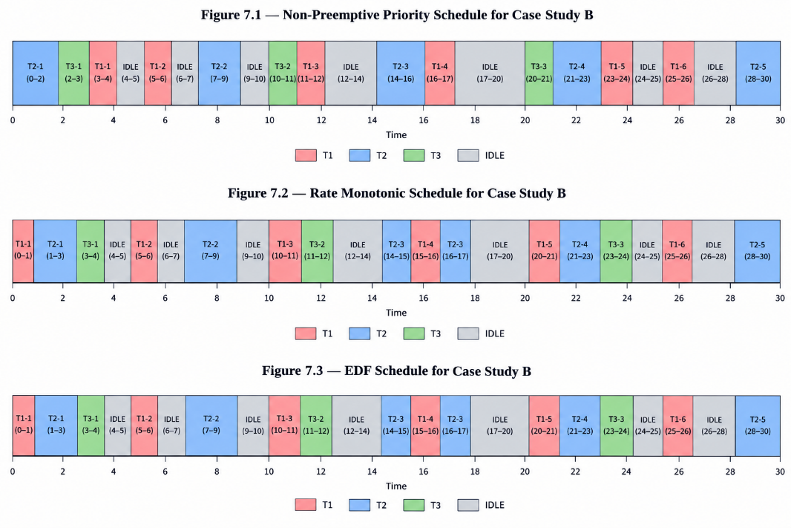
7.3 Per-Job Metrics
The per-job results reveal whether individual jobs finish before their deadlines and how long they wait for CPU service.
Non-Preemptive Priority
Insert the per-job metrics table produced by the Priority implementation.
Rate Monotonic
Insert the per-job metrics table produced by the RM implementation.
Earliest Deadline First
Insert the per-job metrics table produced by the EDF implementation.
The following fields should be included in each table:
Job | Arrival | Burst | Deadline | Start | Completion | Turnaround | Waiting | Response | Deadline Status
Insert actual output | — | — | — | — | — | — | — | — | —
The row above is a table template, not a measured job result. Replace it with the actual rows produced by each implementation.
7.4 Summary of Average Metrics
The final numerical comparison for Case Study B must be based on the simulator output.
Metric | Non-Preemptive Priority | RM | EDF
Average Waiting Time | Insert actual result | Insert actual result | Insert actual result
Average Turnaround Time | Insert actual result | Insert actual result | Insert actual result
Average Response Time | Insert actual result | Insert actual result | Insert actual result
CPU Idle Time | Insert actual result | Insert actual result | Insert actual result
Measured CPU Utilization | Insert actual result | Insert actual result | Insert actual result
Missed Deadlines | Insert actual result | Insert actual result | Insert actual result
Figure 7.4 — Average time metrics and CPU utilization for Case Study B.
Insert a chart generated from the final results table.
Because Case Study B has a high theoretical utilization, small delays may affect deadline satisfaction. The number of missed deadlines should therefore be discussed alongside the average time metrics.
7.5 Analysis
Case Study B highlights the differences between manual priority, fixed period-based priority, and dynamic deadline-based priority.
Under Non-Preemptive Priority Scheduling, X has the higher manually assigned priority. However, a running job cannot be interrupted. If a job of Y begins executing, a newly released job of X must wait until the current job completes. This is an important limitation of the non-preemptive policy when the workload is close to full processor utilization.
Under RM, X has the higher priority because its period is shorter. A running Y job can be preempted when a new X job becomes ready. This fixed priority assignment may protect X jobs, but it does not consider the absolute deadline of each individual job when selecting between ready jobs.
Under EDF, the scheduler compares absolute deadlines. This can allow a job with a later release time to execute before another job if its absolute deadline is earlier.
The actual results must determine which jobs complete on time in the implemented simulation. It would be incorrect to assume that Non-Preemptive Priority necessarily behaves like RM, or to claim that RM necessarily misses a deadline solely because utilization exceeds the sufficient bound.
The main lesson from this case study is that scheduling behavior depends on the combination of task computation times, periods, deadlines, priority rules, preemption behavior, and simulation assumptions. The theoretical utilization conditions provide useful guidance, while the simulator illustrates the execution-level consequences.
8. Comparative Analysis
This section summarizes the main theoretical and practical differences between Non-Preemptive Priority, RM, and EDF.
8.1 Qualitative Comparison
Property | Non-Preemptive Priority | RM | EDF
Priority Type | Manually assigned | Fixed according to period | Dynamic according to absolute deadline
Preemptive? | No | Yes | Yes
Main Scheduling Rule | Highest-priority ready process | Ready job with shortest-period task's priority | Ready job with earliest absolute deadline
Designed For | General process scheduling with explicit priorities | Periodic real-time tasks | Deadline-driven real-time tasks
Priority Changes at Runtime | No | No | Yes, according to the ready jobs' deadlines
Response to a New Urgent Job | Waits for running process to finish | Can preempt a lower-priority job | Can preempt a job with a later deadline
Classical Schedulability Condition | No general guarantee from priority alone | Sufficient bound under classical assumptions | (U\leq1) under classical periodic-task assumptions
Scheduling Overhead | Relatively low | Relatively low due to fixed priorities | Often higher due to dynamic deadline comparisons
Starvation Risk | Possible for low-priority processes | Possible for lower-priority tasks under sustained demand | Depends on workload and overload behavior
Main Advantage | Simple and explicitly configurable | Stable priorities and established analysis | Adapts to the urgency of individual jobs
Main Limitation | Cannot preempt a running process | Priorities do not adapt to individual deadlines | Dynamic scheduling and overload behavior can be more complex
Typical Use | Systems with explicit process priorities | Periodic real-time systems | Real-time systems requiring dynamic deadline scheduling
The classical RM utilization bound is a sufficient condition, not a maximum utilization limit. Similarly, EDF's theoretical utilization guarantee depends on the assumptions of the scheduling model. These distinctions are important when interpreting the comparison.
8.2 Quantitative Comparison Across Both Case Studies
The following table combines the metrics from Case Study A and Case Study B. Case Study A contains the previously recorded sample values, which must be checked against the final program output. Case Study B must be completed using the actual simulator results.
Metric | Priority (A) | RM (A) | EDF (A) | Priority (B) | RM (B) | EDF (B)
Average Waiting Time | 0.71 | 0.64 | 0.64 | Actual result | Actual result | Actual result
Average Turnaround Time | 2.07 | 2.00 | 2.00 | Actual result | Actual result | Actual result
Average Response Time | 0.71 | 0.57 | 0.57 | Actual result | Actual result | Actual result
CPU Idle Time | 11 | 11 | 11 | Actual result | Actual result | Actual result
Measured CPU Utilization | 63.33% | 63.33% | 63.33% | Actual result | Actual result | Actual result
Missed Deadlines | 0 | 0 | 0 | Actual result | Actual result | Actual result
Note: The Case Study A values are sample results and must be verified. Case Study B values must be taken directly from the final program output. Do not leave the words “Actual result” in the submitted report.
The quantitative comparison should be used to evaluate the observed performance, not to claim that one algorithm is always superior. The best algorithm depends on the scheduling requirements, workload, and assumptions.
9. Discussion
The comparison demonstrates that the three scheduling algorithms use different criteria to decide which job should execute next.
Non-Preemptive Priority Scheduling uses explicit priorities. This makes it relatively simple and allows the designer to reflect the importance of individual processes. However, its non-preemptive nature means that a high-priority process may be delayed by a lower-priority process that is already running. This can be a serious limitation in time-sensitive applications.
Rate Monotonic uses fixed priorities determined by task periods. Shorter-period tasks always receive higher priority. This makes RM relatively easy to analyze and can provide useful schedulability guarantees under its classical assumptions. However, the priority of a task does not change when the urgency of an individual job changes.
Earliest Deadline First uses dynamic priorities based on absolute deadlines. This allows the scheduler to react to the deadlines of individual jobs rather than relying only on fixed task priorities. Under the classical single-processor periodic-task model, EDF can schedule feasible workloads with utilization up to 100%.
The case studies illustrate why performance metrics should be evaluated together. Average waiting time, turnaround time, and response time describe different aspects of performance. Deadline satisfaction, on the other hand, indicates whether a real-time requirement has been fulfilled.
A low average waiting time does not necessarily mean that every deadline is met. Likewise, a schedule that meets every deadline may not produce the lowest average response time for every task.
CPU utilization also requires careful interpretation. The theoretical utilization of a periodic workload is not necessarily equal to measured utilization over a finite simulation interval. The difference can depend on the simulation horizon, job release rules, completion behavior, and the treatment of jobs that remain unfinished at the end of the interval.
The results should therefore be interpreted within the limits of the implemented simulation. The algorithms are being compared under the same task definitions, but they do not have identical scheduling capabilities. In particular, Non-Preemptive Priority cannot interrupt a running process, whereas RM and EDF can preempt jobs according to their scheduling rules.
For a practical system, the choice of scheduling algorithm should be based on whether the main requirement is simple priority-based execution, predictable fixed-priority scheduling, or dynamic deadline management.
10. Conclusion
This report compared Non-Preemptive Priority, Rate Monotonic, and Earliest Deadline First scheduling through algorithm descriptions, flowcharts, pseudocode, periodic task sets, Gantt charts, and performance metrics.
Non-Preemptive Priority Scheduling is straightforward and supports explicit priority assignments. Its main limitation is that a running process cannot be interrupted, which may delay more urgent processes that arrive later. Low-priority processes may also experience starvation under sustained high-priority demand.
Rate Monotonic provides fixed priorities based on task periods. Its stable priority assignment supports analysis of periodic real-time workloads. However, its priorities do not adapt to the changing urgency of individual jobs, and the classical utilization bound is sufficient rather than necessary.
Earliest Deadline First dynamically selects jobs according to their absolute deadlines. Under the classical single-processor assumptions, it can meet every deadline for feasible periodic task sets with deadlines equal to periods and utilization no greater than 100%. Its dynamic scheduling decisions may, however, introduce additional implementation complexity.
The case studies provide a framework for evaluating these differences. Case Study A examines a moderately loaded workload, while Case Study B examines a high-utilization workload. The final numerical conclusions must be based on the verified output of the implemented simulators.
Overall, no scheduling algorithm should be selected solely because it performs well on one metric or one task set. The appropriate choice depends on processor demand, deadline requirements, preemption behavior, priority policy, and the practical constraints of the system.
References
- Liu, C. L., & Layland, J. W. (1973). Scheduling Algorithms for Multiprogramming in a Hard-Real-Time Environment. Journal of the ACM, 20(1), 46–61.
- Silberschatz, A., Galvin, P. B., & Gagne, P. B. (2018). Operating System Concepts (10th ed.). Wiley.
- Buttazzo, G. C. (2011). Hard Real-Time Computing Systems: Predictable Scheduling Algorithms and Applications (3rd ed.). Springer.
- Stallings, W. (2017). Operating Systems: Internals and Design Principles (9th ed.). Pearson.
- Tanenbaum, A. S., & Bos, H. (2014). Modern Operating Systems (4th ed.). Pearson.
- Python Software Foundation. Python 3 Documentation. https://docs.python.org/3/

